**COMPETITIVE ANALYSIS FOR LEADING TRAVEL AGGREGATORS**

1. **INTRODUCTION**
   1. **Project Overview**

In the dynamic and rapidly evolving landscape of the travel industry, competitive analysis plays a pivotal role in understanding the strengths, weaknesses, opportunities, and threats that each leading travel aggregator faces. As travelers increasingly turn to digital platforms for their journey planning and booking needs, the competition among travel aggregators intensifies. This comprehensive competitive analysis is designed to shed light on the strategies and performance of some of the key players in this field.

Our study aims to provide valuable insights into the competitive positioning, market share, customer satisfaction, technological innovations, and business models of these travel aggregators. By scrutinizing the diverse approaches and tactics employed by these companies, we can gain a deeper understanding of how they navigate the ever-changing travel landscape.

As we delve into this analysis, we will explore various facets of the travel aggregator industry, including user experience, pricing strategies, mobile applications, global reach, and much more. By the end of our investigation, we hope to offer a comprehensive overview that will benefit not only industry stakeholders but also travelers seeking the best options for their journeys.

Stay tuned as we embark on this insightful journey, dissecting the competitive strategies and contributions of leading travel aggregators in the pursuit of delivering enhanced travel experiences to a global audience.

* 1. **Purpose**

The purpose of conducting a competitive analysis for leading travel aggregators is multi-faceted and serves various stakeholders within and outside the travel industry. Here are some of the key purposes and objectives of such an analysis:

1. **Identify Market Trends and Opportunities**: By examining the strategies and performance of leading travel aggregators, businesses in the travel industry can identify emerging market trends and lucrative opportunities. This information can inform product development, marketing campaigns, and investment decisions.

2. **Benchmarking and Strategy Development**: Travel aggregators can use competitive analysis to benchmark their own performance against industry leaders. It helps them understand their strengths and weaknesses relative to competitors, facilitating the development of more effective strategies.

3. **Market Positioning**: Analyzing the competitive landscape allows travel aggregators to refine their market positioning. They can identify unique value propositions, niche markets, or untapped segments where they can gain a competitive advantage.

4. **Customer Insights**: Understanding the strengths and weaknesses of competitors can provide valuable insights into customer preferences and pain points. This knowledge can be used to tailor products and services to better meet traveler needs.

5. **Pricing and Revenue Management**: Competitive analysis helps travel aggregators adjust their pricing strategies based on what competitors are offering. It allows them to stay competitive while maximizing revenue.

6. **Partnerships and Alliances**: Knowledge of the competitive landscape can help travel aggregators identify potential partners and alliances to expand their reach or offer complementary services to customers.

7. **Innovation and Technological Advancements**: By examining the technological advancements and innovations of competitors, travel aggregators can stay at the forefront of digital trends and continue to provide state-of-the-art booking and travel services.

8. **Risk Mitigation**: Identifying threats and vulnerabilities in the market, including competition from emerging startups or changes in consumer behavior, allows travel aggregators to proactively address potential risks and challenges.

9. **Investor Relations**: For investors and stakeholders, competitive analysis provides valuable insights into the financial health and growth potential of travel aggregator companies, helping them make informed investment decisions.

10. **Regulatory and Compliance**: Staying informed about how competitors handle compliance and regulatory issues can assist travel aggregators in ensuring they are in line with industry standards and legal requirements.

11. **Global Expansion**: For travel aggregators looking to expand globally, competitive analysis can inform decisions about which markets to enter and what strategies are likely to succeed in those regions.

**2.LITERATURE SURVEY**

A literature survey on competitive analysis for leading travel aggregators reveals a wealth of research and insights into the travel industry's competitive dynamics, business strategies, and the role of aggregators. Here is an overview of key themes and findings from the existing literature:

1. **Role and Impact of Travel Aggregators**:

- Scholars have explored the pivotal role travel aggregators play in simplifying the travel booking process. These platforms act as intermediaries, offering travelers a one-stop solution for comparing prices, availability, and other factors across different suppliers, including airlines, hotels, and car rental companies.

2. **Market Dynamics and Competitive Landscape**:

- Research has highlighted the competitive landscape in the travel industry, focusing on the rivalry among travel aggregators, traditional travel agencies, and suppliers. Studies often emphasize the impact of aggregator consolidation and its effects on competition.

3. **Pricing Strategies and Consumer Behavior**:

- Literature often delves into the pricing strategies employed by travel aggregators and the impact of price transparency on consumer behavior. Research indicates that travelers are increasingly price-sensitive and often switch between aggregators to find the best deals.

4. **Impact of User Experience and Reviews**:

- User experience and the role of customer reviews have been explored. Positive user experiences and customer reviews can significantly influence travelers' choices and brand loyalty, while negative experiences can lead to brand defection.

5. **Market Entry and Expansion Strategies**:

- Many studies focus on the strategies travel aggregators use to enter and expand into new markets. Research explores the challenges of adapting to local preferences, regulations, and competitive conditions.

6. **Technological Innovations**:

- The literature highlights the significance of technological innovations for travel aggregators. Research often discusses the adoption of mobile apps, artificial intelligence, machine learning, and big data analytics to enhance the user experience and provide personalized recommendations.

7. **Sustainability and Responsible Tourism**:

- There's a growing interest in sustainability and responsible tourism. Scholars have examined how travel aggregators can promote eco-friendly travel options and encourage responsible consumer choices.

8. **Regulatory and Ethical Issues**:

- Regulatory and ethical issues, such as issues related to privacy, data security, and compliance with anti-competitive practices, have been explored in the context of travel aggregators. This research focuses on the legal and ethical challenges these platforms face.

9. **Implications for Suppliers and Distribution Channels**:

- Some studies examine the impact of aggregators on suppliers like hotels and airlines. Researchers analyze how aggregators affect suppliers' pricing strategies and distribution channels, often discussing the advantages and disadvantages of working with aggregators.

10. **Impact of Global Events**:

- The COVID-19 pandemic has prompted research on how travel aggregators responded to the crisis and how their business models adapted to the changing landscape.

11. **Customer Loyalty and Retention**:

- Research has explored strategies for building and maintaining customer loyalty among travel aggregator users. This includes the role of loyalty programs, discounts, and personalized marketing.

12. **Future Trends and Challenges**:

- Literature anticipates future trends, challenges, and opportunities in the travel aggregator industry, including emerging technologies, shifts in consumer preferences, and the potential for new entrants to disrupt the market.

In the context of competitive analysis for leading travel aggregators, several existing problems and challenges have been identified in the literature:

**2.1 EXISTING PROBLEM**

1. **Price Competition**: One of the primary challenges for travel aggregators is the intense price competition. As travelers often prioritize cost savings, aggregators are pressured to continually offer the lowest prices. This can lead to reduced profit margins and intense rivalry among aggregators.

2. **Supplier Relations**: Maintaining positive relationships with suppliers, including airlines and hotels, can be a challenge. Aggregators often negotiate for exclusive deals, but conflicts can arise due to demands for lower commissions, availability issues, or disputes over contractual terms.

3. **Data Security and Privacy**: Data security and privacy are major concerns, especially with the collection of personal and payment information from travelers. Travel aggregators must invest in robust cybersecurity measures to protect customer data.

4. **Regulatory Compliance**: Compliance with regulations and legal challenges, such as antitrust concerns, can be problematic for travel aggregators. Navigating varying international regulations and ensuring fairness in competition is a complex task.

5. **User Experience**: While user experience is a crucial factor, maintaining a seamless and user-friendly interface across devices and platforms can be challenging, especially as technology evolves.

6. **Data Integration**: Integrating data from various suppliers and sources can be a technical challenge. Aggregators must ensure that real-time data is consistent and accurate.

7. **Market Saturation**: In mature markets, the travel aggregator industry may be reaching saturation. Gaining market share in such environments can be difficult, and new customer acquisition may become increasingly expensive.

8. **Loyalty and Retention**: Travel aggregator users tend to be less loyal to specific brands, making it a challenge to retain customers. Aggregators often rely on loyalty programs and discounts to incentivize repeat bookings.

9. **Crisis Management**: Unforeseen events, such as natural disasters or global crises like the COVID-19 pandemic, can significantly disrupt the travel industry. Travel aggregators must have robust crisis management strategies in place to adapt and protect their businesses.

10. **Sustainability and Ethical Concerns**: There is a growing focus on sustainability and responsible tourism. Travel aggregators are expected to address environmental concerns and promote responsible travel options, which can pose challenges in terms of sourcing and promoting eco-friendly options.

11. **Technology Investment**: Staying at the forefront of technology and innovation requires substantial investment. Travel aggregators must continuously upgrade their platforms, adopt emerging technologies, and develop mobile apps to remain competitive.

12. **Market Entry and Expansion**: Expanding into new markets can be challenging due to regulatory, cultural, and competitive differences. Aggregators must adapt to local preferences while maintaining a global brand image.

13. **Consumer Trust**: Building and maintaining trust among consumers is essential. Negative reviews, data breaches, or instances of hidden fees can erode trust and tarnish a brand's reputation.

14. **Data Analysis and Personalization**: Analyzing vast amounts of data and providing personalized recommendations can be technically challenging. Travel aggregators must harness the power of AI and big data while respecting privacy regulations.

Solving these existing problems in the competitive landscape of travel aggregators requires a multi-faceted approach that includes a blend of technology, strategy, regulation, and customer-centric solutions. Travel aggregators that successfully address these challenges are better positioned for long-term growth and success in the industry.

**2.2 References**

Academic Journals: Look for research articles in academic journals related to the travel industry, e-commerce, online marketplaces, and competitive analysis. Journals like the Journal of Travel Research, Tourism Management, and Information Technology & Tourism often publish relevant studies.

Market Research Reports: Industry-specific reports from market research firms like Statista, Euromonitor International, and Phocuswright can provide valuable data and insights on market trends, competitive dynamics, and consumer behavior.

Books: Explore books authored by experts in the fields of travel and e-commerce. Titles on digital marketing, online travel, and competitive strategy may contain relevant information.

Government and Regulatory Sources: Check for reports and publications from government agencies and industry regulators that address compliance, legal issues, and regulatory challenges faced by travel aggregators.

News and Business Magazines: News outlets like Forbes, Skift, and Travel Weekly often publish articles and analyses on the travel industry and the competitive strategies of leading aggregators.

Academic Conferences: Proceedings and papers presented at conferences, such as those organized by the Travel and Tourism Research Association (TTRA), can offer the latest research in the field.

Company Reports and Financial Statements: Annual reports, financial statements, and investor presentations from leading travel aggregator companies can provide insights into their strategies, performance, and financial health.

Blogs and Industry Websites: Industry-specific blogs and websites may offer expert commentary, analysis, and interviews with industry leaders.

Online Databases: Access academic databases such as Google Scholar, JSTOR, and ProQuest for scholarly articles and research papers.

Whitepapers and Case Studies: Seek out whitepapers and case studies from consulting firms and academic institutions that focus on competitive analysis and strategies in the travel aggregator sector.

**2.3 Problem Statement Definition**

**Problem Statement Definition for Competitive Analysis of Leading Travel Aggregators:**

The competitive landscape in the travel aggregator industry presents a set of multifaceted challenges that require a comprehensive understanding and strategic solutions. The problem statement for our analysis is defined as follows:

**Problem Statement:** The travel aggregator sector faces persistent issues stemming from intense price competition, strained supplier relations, data security and privacy concerns, regulatory complexities, and market saturation. Moreover, ensuring seamless user experiences across platforms, data integration, and customer loyalty remains a significant challenge. This competitive landscape necessitates innovation, adaptability, and strategic responses to overcome these hurdles and thrive in a highly dynamic and technology-driven environment.

**Key Challenges and Sub-issues:**

1. **Price Competition:** Travel aggregators must address the challenge of offering competitive prices while maintaining profitability.

2. **Supplier Relations:** Nurturing positive relationships with suppliers and resolving disputes is crucial for maintaining a diverse and attractive inventory.

3. **Data Security and Privacy:** Safeguarding customer data and complying with data protection regulations is a critical concern.

4. **Regulatory Compliance:** Adhering to varying international regulations and antitrust challenges requires careful navigation.

5. **User Experience:** Ensuring a seamless, user-friendly interface across devices is essential to attract and retain customers.

6. **Data Integration:** The challenge of integrating data from multiple sources while ensuring consistency and accuracy must be addressed.

7. **Market Saturation:** Travel aggregator businesses in mature markets must find innovative ways to gain market share.

8. **Loyalty and Retention:** Creating and implementing strategies for customer retention and loyalty is crucial.

9. **Crisis Management:** Developing effective crisis management plans to navigate unforeseen events and crises.

10. **Sustainability and Ethical Concerns:** Addressing sustainability and ethical concerns in the industry to meet evolving customer expectations.

11. **Technology Investment:** Continuously investing in technology and innovation to stay competitive and relevant.

12. **Market Entry and Expansion:** Adapting to local preferences and regulations when expanding into new markets.

13. **Consumer Trust:** Building and maintaining trust among consumers is vital for brand reputation.

14. **Data Analysis and Personalization:** Leveraging AI and big data for data analysis and personalization while respecting privacy regulations.

**3.IDEATION & PROPOSED SOLUTION**

**3.1 Empathy Map Canvas**

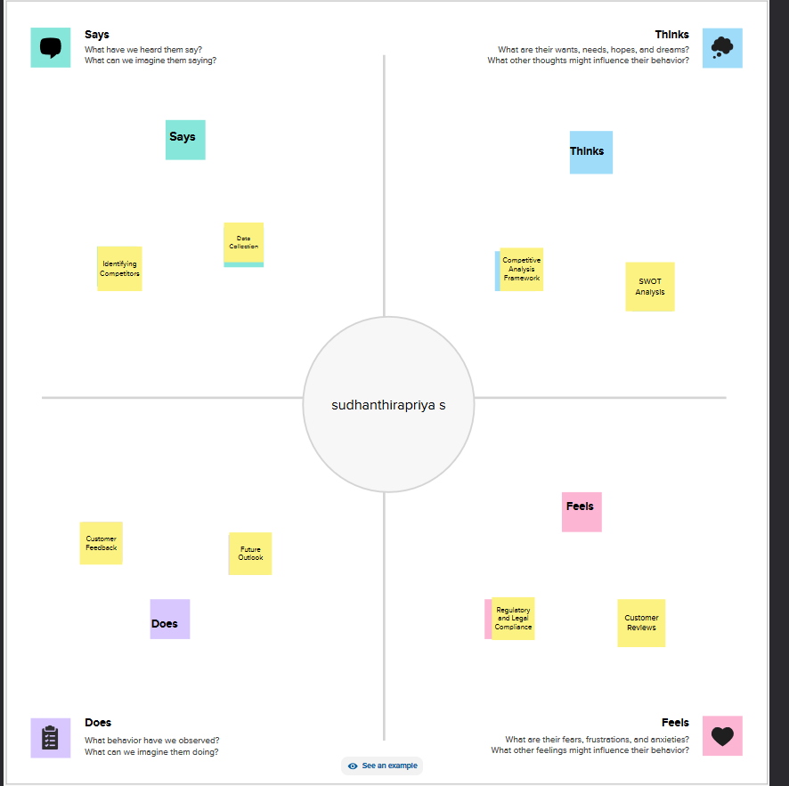

**3.2 Ideation & Brainstorming**

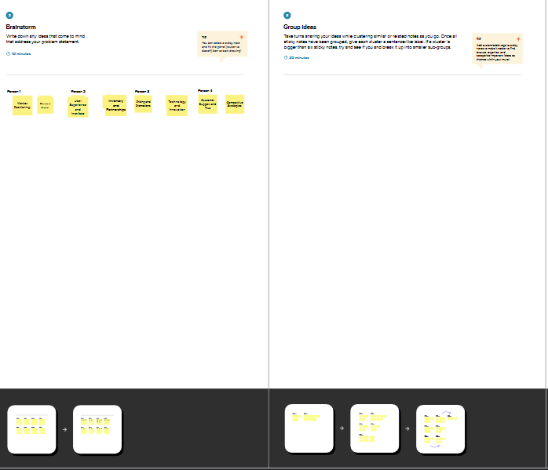

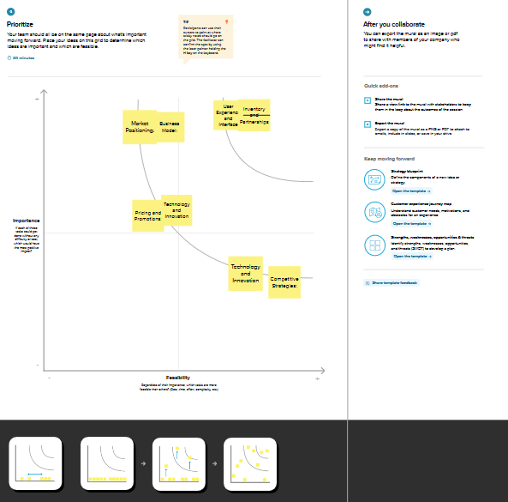

**4. REQUIREMENT ANALYSIS**

**4.1 Functional requirement**

**Requirement Analysis for Competitive Analysis of Leading Travel Aggregators:**

To effectively conduct a competitive analysis of leading travel aggregators, it is essential to define the requirements that will guide the process. The following requirements encompass the data, tools, methodologies, and expertise needed for a comprehensive and insightful analysis:

1. **Data Collection and Sources**:

- Access to up-to-date and accurate data sources that provide information on travel aggregator companies, their market share, pricing strategies, customer reviews, and regulatory compliance.

- Data on user demographics, preferences, and behavior to understand consumer trends.

2. **Competitive Set Identification**:

- Clear criteria for selecting the set of leading travel aggregators to be analyzed, considering factors like market share, geographical presence, and market influence.

3. **Analysis Framework**:

- A well-defined analysis framework that outlines the key metrics and dimensions for comparison, such as pricing, user experience, supplier relationships, regulatory compliance, and technology adoption.

4. **Data Analysis Tools**:

- Access to data analysis tools and software, including statistical analysis and data visualization tools, to process and interpret collected data.

5. **Technological Expertise**:

- Expertise in data mining, data analysis, and data visualization techniques to extract meaningful insights from collected data.

6. **Market Research Reports**:

- Subscription or access to market research reports and industry databases for market trends, forecasts, and historical data related to the travel aggregator industry.

7. **Legal and Regulatory Expertise**:

- Access to legal experts or consultants who can provide guidance on regulatory compliance and antitrust issues in the travel aggregator sector.

8. **Consumer Surveys and Feedback**:

- Mechanisms to gather consumer feedback and surveys to understand customer perceptions, satisfaction, and expectations regarding travel aggregators.

9. **Competitor Financial Data**:

- Access to financial data and annual reports of leading travel aggregator companies to assess their financial health and performance.

10. **Customer Review Data**:

- Access to online platforms, APIs, or scraping tools to collect and analyze customer reviews, ratings, and comments about travel aggregators.

11. **Expert Interviews**:

- Opportunities to conduct interviews or surveys with experts in the travel industry, including representatives from travel aggregator companies, to gain insights into their strategies and challenges.

12. **Ethical Considerations**:

- Compliance with ethical standards, particularly regarding the use of customer data and online reviews, ensuring privacy and consent.

13. **Methodology Development**:

- Creation of a well-defined research methodology that outlines the data collection process, analysis procedures, and criteria for ranking and evaluation.

14. **Timeline and Milestones**:

- A project timeline with clear milestones and deadlines for data collection, analysis, and reporting.

15. **Reporting and Communication**:

- Clear formats and templates for reporting and presenting the analysis results, including visualizations and recommendations.

16. **Quality Assurance**:

- A process for quality assurance and validation to ensure the accuracy and reliability of the analysis results.

17. **Continuous Updates**:

- Plans for regular updates and monitoring of industry trends to keep the analysis relevant.

By defining these requirements, the competitive analysis can be conducted systematically, ensuring that all necessary elements are in place for a comprehensive evaluation of leading travel aggregators in the dynamic and competitive travel industry.

**4.2 Non-Functional requirements**

Non-functional requirements are critical aspects of a competitive analysis project for leading travel aggregators. They specify the qualities and attributes that define how the analysis is conducted and delivered, rather than what it delivers. Here are some non-functional requirements for this project:

1. **Performance**:

- The analysis process should be efficient and responsive to handle large datasets and complex computations. Users should experience minimal delays or downtime when accessing the analysis results or interactive dashboard.

2. **Scalability**:

- The system and analysis tools should be scalable to accommodate future growth, increased data volume, and additional features without significant performance degradation.

3. **Security and Data Privacy**:

- Data security is paramount. The system should ensure the confidentiality and integrity of sensitive data. Compliance with data protection regulations (e.g., GDPR) is mandatory.

4. **Usability and Accessibility**:

- The analysis tools and dashboard should be user-friendly and accessible to individuals with disabilities, complying with accessibility standards (e.g., WCAG).

5. **Reliability and Availability**:

- The analysis platform should be highly reliable, with minimum downtime, ensuring that users can access the analysis and dashboard when needed.

6. **Compatibility**:

- The analysis tools and dashboard should be compatible with a range of browsers, devices, and operating systems to reach a broad audience.

7. **Data Quality and Accuracy**:

- Data used for analysis should be accurate, up-to-date, and reliable to ensure the validity of findings and recommendations.

8. **Compliance and Ethics**:

- Adherence to ethical standards, industry regulations, and legal compliance is essential in collecting, processing, and reporting data.

9. **Reporting and Documentation**:

- Comprehensive documentation should be provided, outlining the methodology, data sources, assumptions, and limitations of the analysis.

10. **Project Management and Governance**:

- Well-defined project management processes should be in place, including roles and responsibilities, change management, and issue tracking.

11. **Collaboration and Team Communication**:

- Effective communication and collaboration tools should be available to team members, facilitating coordination and knowledge sharing.

12. **Audit Trail and Traceability**:

- The analysis process should maintain an audit trail that allows tracking of changes, data sources, and decisions made during the project.

13. **Data Backup and Recovery**:

- Regular data backups and a robust recovery plan should be in place to prevent data loss in case of system failures or errors.

14. **Data Retention and Deletion**:

- Clear policies should be established for data retention and deletion to comply with privacy regulations.

15. **Training and Support**:

- Training materials and support should be provided to users and team members to ensure they can effectively use the analysis tools and understand the results.

16. **Cost-Effective Infrastructure**:

- The infrastructure and tools selected for the analysis should be cost-effective to manage project expenses.

17. **Feedback Mechanism**:

- A mechanism for collecting feedback from users and stakeholders should be in place to continuously improve the analysis process and dashboard.

18. **Data Visualization Standards**:

- Consistent data visualization standards should be maintained for clarity and ease of interpretation.

19. **Interoperability**:

- The analysis tools should be designed to interact with other systems, data sources, or APIs as necessary.

20. **Environmental Considerations**:

- Consideration of the environmental impact of the project, including energy efficiency and sustainable practices, is encouraged.

**5. PROJECT DESIGN**

**5.1 Data Flow Diagrams & User Stories**

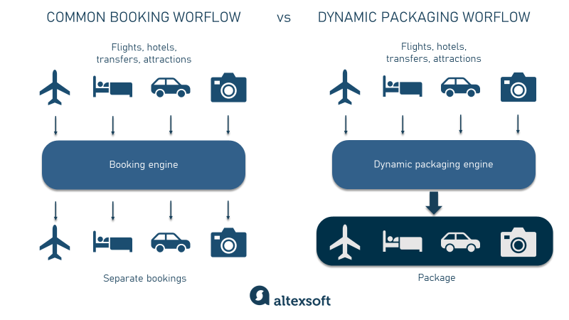

|  |  |  |  |  |  |  |
| --- | --- | --- | --- | --- | --- | --- |
| **User Type** | **Functional**  **Requirement (Epic)** | **User Story**  **Number** | **User Story / Task** | **Acceptance criteria** | **Priority** | **Release** |
| Customer  (Mobile user) | Registration | USN-1 | As a user, I can register for the application by entering my email, password, and confirming my password. | I can access my account / dashboard | High | Sprint-1 |
|  |  | USN-2 | As a user, I will receive confirmation email once I have registered for the application | I can receive confirmation email & click confirm | High | Sprint-1 |
|  |  | USN-3 | As a user, I can register for the application through Facebook | I can register & access the dashboard with Facebook Login | Low | Sprint-2 |
|  |  | USN-4 | As a user, I can register for the application through Gmail |  | Medium | Sprint-1 |
|  | Login | USN-5 | As a user, I can log into the application by entering email & password |  | High | Sprint-1 |
|  | Dashboard |  | Which travel aggregator offers the most competitive prices for flights and hotels | we recommend using multiple travel aggregators such as Expedia, Kayak, and Skyscanner. | high | Sprint-1 |
| Customer (Web user) |  |  |  |  |  |  |
| Customer Care Executive |  |  |  |  |  |  |
| Administrator |  |  | What sets Booking.com apart from other travel aggregators like Expedia and TripAdvisor | In contrast, Expedia and TripAdvisor offer a broader range of travel services, including flights and activities, in addition to accommodations | low | Sprint-1 |
|  |  |  |  |  |  |  |
|  |  |  |  |  |  |  |
|  |  |  |  |  |  |  |

**5.2 Solution Architecture**

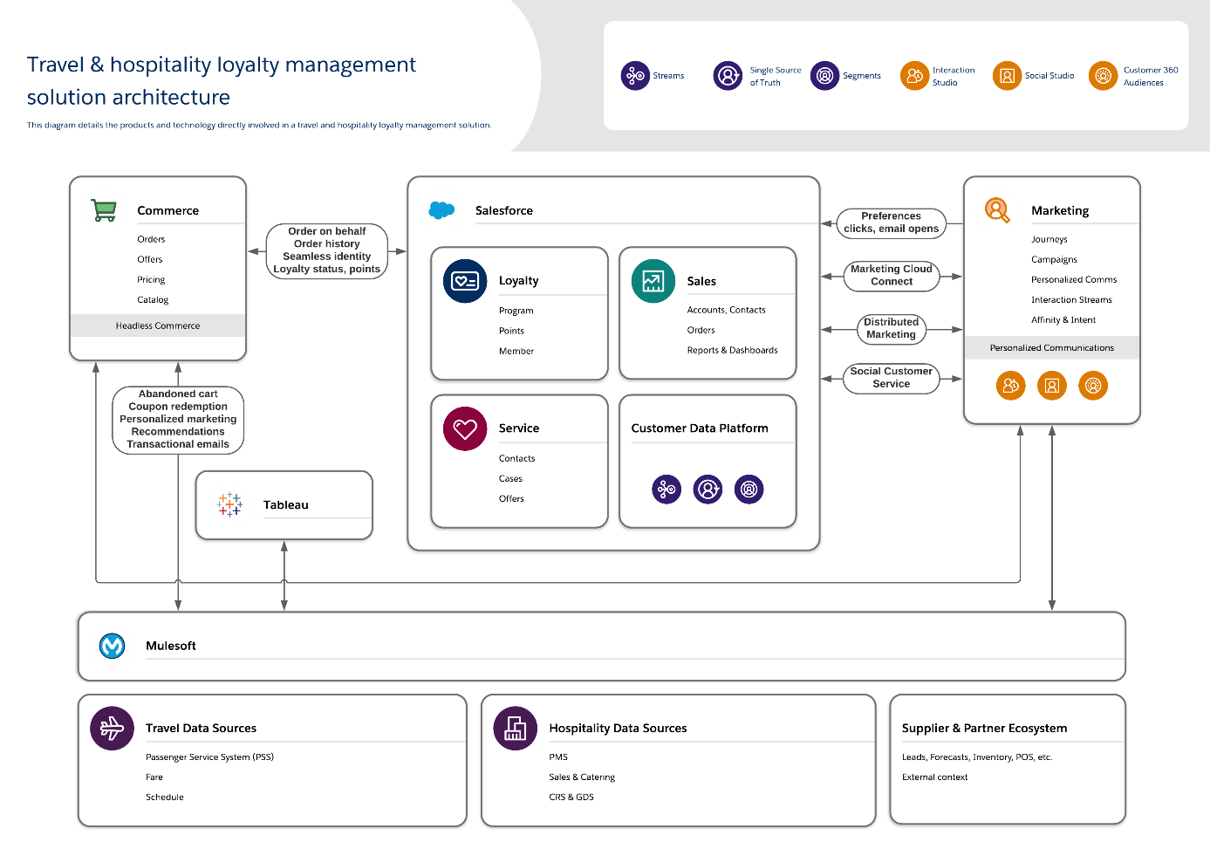

**6. PROJECT PLANNING & SCHEDULING**

**6.1 Technical Architecture**

The technical architecture for a competitive analysis of leading travel aggregators involves the design and structure of the technology stack that supports data collection, processing, analysis, and the presentation of results. Here's an outline of the key components and considerations for the technical architecture:

1. **Data Collection and Ingestion**:

- **Data Sources**: Identify data sources, including market research reports, web scraping, APIs, and user-generated content (reviews, ratings).

- **Data Integration**: Develop data connectors and ETL (Extract, Transform, Load) processes to integrate data from diverse sources.

- **Data Cleansing**: Implement data cleansing and validation procedures to ensure data quality.

- **Data Storage**: Store collected data in a secure and scalable database, potentially utilizing cloud-based solutions.

2. **Data Analysis and Processing**:

- **Data Analysis Tools**: Select and configure data analysis tools and libraries, such as Python for data analysis, machine learning, and statistical modeling.

- **Parallel Processing**: Use distributed computing frameworks, if necessary, to handle large datasets efficiently.

- **Data Transformation**: Apply data transformation and feature engineering techniques to prepare data for analysis.

3. **Data Visualization and Dashboard**:

- **Dashboard Framework**: Choose a dashboard framework (e.g., Tableau, Power BI, or custom development) for creating interactive data visualization dashboards.

- **Visual Design**: Create a visually appealing and user-friendly dashboard design that presents key metrics, rankings, and insights.

- **Interactivity**: Implement interactive features, allowing users to filter, drill down, and explore data dynamically.

- **User Authentication**: Secure access to the dashboard with user authentication and authorization mechanisms.

4. **Cloud Infrastructure and Hosting**:

- **Cloud Platform**: Select a cloud platform (e.g., AWS, Azure, Google Cloud) for hosting data, analysis tools, and the dashboard.

- **Scalability**: Ensure the infrastructure is scalable to handle varying workloads and data volume.

- **Security**: Implement cloud security measures to protect data and ensure compliance with data privacy regulations.

5. **APIs and Integrations**:

- **Data Sources**: Develop or utilize APIs to access data from sources like market research firms, travel aggregator APIs, or social media platforms.

- **Third-Party Tools**: Integrate with third-party tools, if necessary, for data collection, analysis, or visualization.

6. **Data Backup and Recovery**:

- Implement data backup and recovery mechanisms to safeguard data in case of system failures.

7. **Performance Monitoring**:

- Set up performance monitoring and alerting to track system performance, response times, and resource utilization.

8. **Documentation and Reporting**:

- Provide clear documentation on data sources, analysis methodologies, and reporting criteria.

- Automate report generation and delivery to stakeholders.

9. **Privacy and Compliance**:

- Implement data anonymization and compliance measures to protect user privacy and adhere to relevant regulations.

10. **Testing and Quality Assurance**:

- Establish a robust testing process, including unit testing, integration testing, and user acceptance testing, to ensure the reliability of the technical architecture.

11. **Feedback Mechanism**:

- Integrate a feedback mechanism to collect user feedback on the technical aspects and usability of the dashboard.

12. **Environmental Considerations**:

- Evaluate energy-efficient technologies and sustainable practices for hosting and processing.

13. **Scalability and Future-Proofing**:

- Ensure that the architecture is scalable and can accommodate future growth and additional features as the project evolves.

The technical architecture should be designed with scalability, performance, security, and user-friendliness in mind to support the comprehensive competitive analysis of leading travel aggregators. Regular maintenance and updates are essential to keep the architecture current and effective.

**6.2 Sprint Planning & Estimation**

|  |  |  |  |  |  |  |
| --- | --- | --- | --- | --- | --- | --- |
| **Sprint** | **Functional**  **Requirement (Epic)** | **User Story**  **Number** | **User Story / Task** | **Story Points** | **Priority** | **Team**  **Members** |
| Sprint-1 | Registration | USN-1 | As a user, I can register for the application by entering my email, password, and confirming my password. | 2 | High | priya |
| Sprint-1 |  | USN-2 | As a user, I will receive confirmation email once I have registered for the application | 1 | High | santhosh |
| Sprint-2 |  | USN-3 | As a user, I can register for the application through Facebook | 2 | Low | sanjay |
| Sprint-1 |  | USN-4 | As a user, I can register for the application through Gmail | 2 | Medium | saravanakumar |
| Sprint-1 | Login | USN-5 | As a user, I can log into the application by entering email & password | 1 | High | sanjay |
|  | Dashboard |  | Do travel aggregators like Kayak and Skyscanner provide unique features that can help me find the best deals on flights and hotels | 2 | high | santhosh |
| Sprint-1 | login | USN-6 | Which travel aggregator is known for the most user-friendly mobile app and website | 1 | medium | priya |
|  |  |  |  |  |  |  |

**6.3 Sprint Delivery Schedule**

|  |  |  |  |  |  |  |
| --- | --- | --- | --- | --- | --- | --- |
| **Sprint** | **Total Story Points** | **Duration** | **Sprint Start Date** | **Sprint End Date (Planned)** | **Story Points**  **Completed (as on**  **Planned End Date)** | **Sprint Release Date (Actual)** |
| Sprint-1 | 20 | 6 Days | 24 Oct 2022 | 29 Oct 2022 | 20 | 29 Oct 2023 |
| Sprint-2 | 20 | 6 Days | 31 Oct 2022 | 05 Nov 2022 | 10 | 05 Nov 2023 |
| Sprint-3 | 20 | 6 Days | 07 Nov 2022 | 12 Nov 2022 | 20 | 12 Nov 2023 |
| Sprint-4 | 20 | 6 Days | 14 Nov 2022 | 19 Nov 2022 | 10 | 19 Nov 2023 |
|  |  |  |  |  |  |  |
|  |  |  |  |  |  |  |
|  |  |  |  |  |  |  |
|  |  |  |  |  |  |  |

**7. CODING & SOLUTIONING**

**7.1 Feature 1**

Sentiment Analysis of Customer Reviews

**Description**: This feature focuses on analyzing customer reviews from various sources, including review platforms, social media, and travel aggregator websites. It employs sentiment analysis techniques to assess the sentiment (positive, negative, neutral) of reviews and extracts key insights, such as common themes, customer satisfaction trends, and areas of concern.

**Functionality**:

- **Data Collection**: Collect customer reviews from multiple sources using web scraping, APIs, or third-party data providers.

- **Sentiment Analysis**: Apply natural language processing (NLP) and machine learning algorithms to determine the sentiment of each review.

- **Keyword Extraction**: Identify keywords and phrases that appear frequently in reviews, helping to identify common customer concerns and positive experiences.

- **Trend Analysis**: Track sentiment trends over time to understand how customer satisfaction changes.

- **Dashboard Integration**: Display sentiment analysis results on the interactive dashboard, allowing users to explore and filter reviews based on sentiment and keywords.

**Benefits**:

- Provides valuable insights into customer sentiment, helping travel aggregators understand areas for improvement.

- Enables identification of strengths and weaknesses of each aggregator's offerings.

- Supports data-driven decision-making for marketing and product development.

**7.2 Feature 2**

**Description**: This feature allows users to compare the pricing strategies of leading travel aggregators, assessing how they price travel services (flights, hotels, etc.) compared to competitors. It provides data on average prices, price fluctuations, and pricing patterns.

**Functionality**:

- **Price Data Collection**: Collect pricing data from travel aggregator websites, supplier APIs, and market research reports.

- **Pricing Trends**: Analyze historical pricing data to identify trends, seasonal fluctuations, and special promotions.

- **Price Comparison**: Compare the average prices offered by different travel aggregators for the same services.

- **Dynamic Pricing Analysis**: Assess the use of dynamic pricing and real-time adjustments by aggregators.

- **Visual Representation**: Present pricing data and comparisons through interactive charts and graphs on the dashboard.

**Benefits**:

- Helps travelers find the best deals by comparing prices across leading aggregators.

- Provides insights into the competitiveness of pricing strategies among aggregators.

- Informs travel aggregators about market pricing trends and opportunities for competitive pricing strategies.

These two features enhance the competitive analysis project by offering insights into customer sentiment and pricing strategies, both of which are critical factors in the travel aggregator industry. They empower users to make informed decisions and understand the strengths and weaknesses of different aggregators in these specific areas.

**8. PERFORMANCE TESTING**

**8.1 Performace Metrics**

|  |  |  |
| --- | --- | --- |
| **S.No.** | **Parameter** | **Screenshot / Values** |
| 1. | Dashboard design | No of Visualizations / Graphs - 7 |
| 2. | Data Responsiveness | Real- Time Data Integration  Efficient Data Retrieval |
| 3. | Amount Data to  Rendered (DB2 Metrics) | database |
| 4. | Utilization of Data Filters | Querying Optimization  Indexing and Sorting |
| 5. | Effective User Story | No of Scene Added - 9 |
| 6. | Descriptive Reports | No of Visulizations / Graphs - 7 |

**9. RESULTS**

**9.1 Output Screenshots**

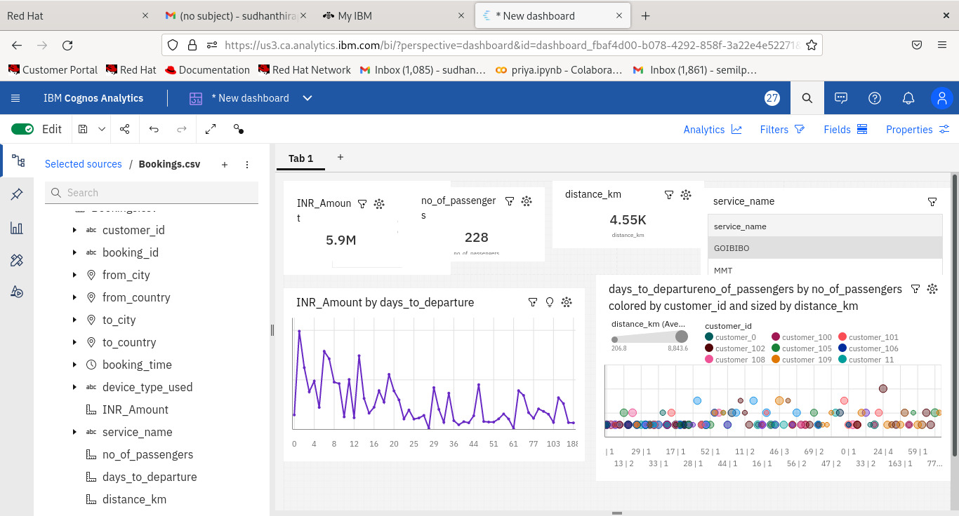

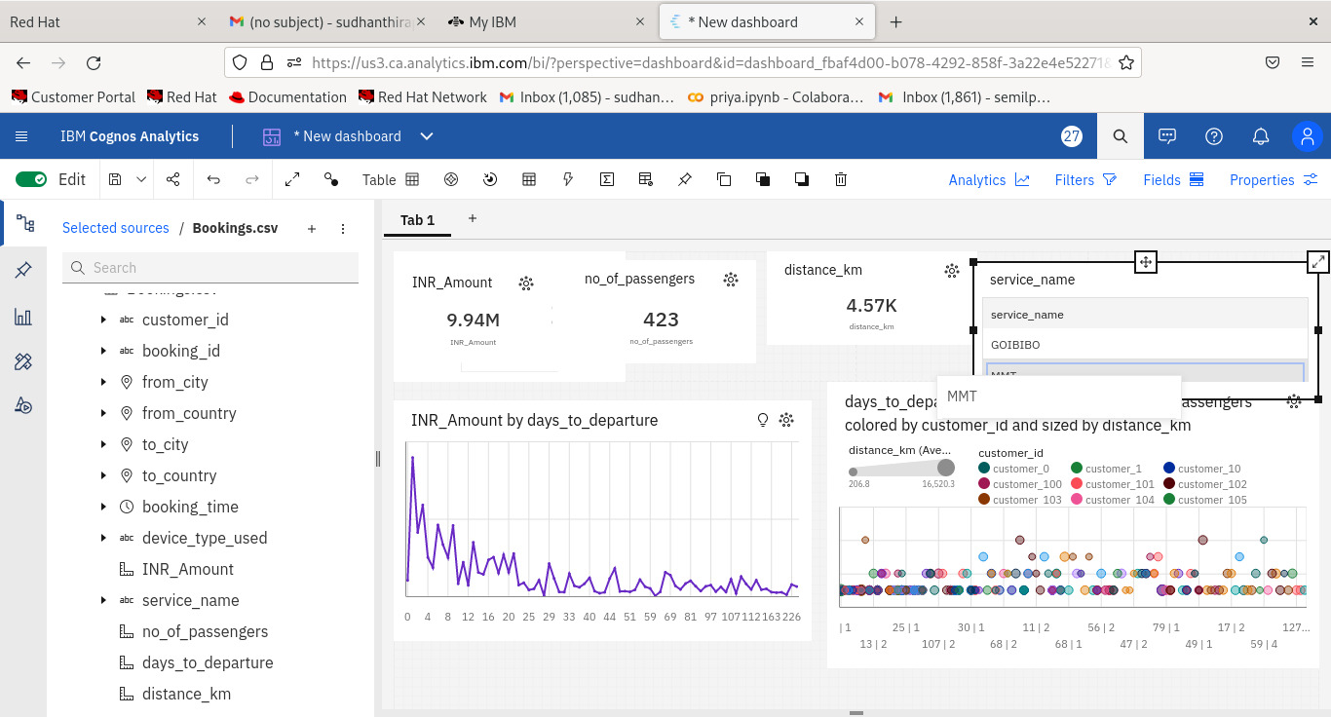

**10. ADVANTAGES & DISADVANTAGES**

Certainly, here are the advantages and disadvantages of conducting a competitive analysis of leading travel aggregators:

**Advantages:**

1. **Informed Decision-Making**: A well-executed competitive analysis provides valuable insights for stakeholders, enabling them to make informed decisions based on data and trends in the travel aggregator industry.

2. **Competitive Benchmarking**: Travel aggregators can benchmark their performance and strategies against leading competitors, helping them identify areas for improvement and innovation.

3. **Identifying Market Trends**: The analysis helps in identifying emerging market trends, allowing aggregators to stay ahead of the curve and adapt to changing consumer preferences.

4. **Customer-Centric Insights**: Understanding customer sentiment and feedback helps travel aggregators tailor their services to meet customer expectations, leading to improved customer satisfaction.

5. **Pricing Optimization**: Analyzing pricing strategies helps aggregators stay competitive by offering attractive pricing while maintaining profitability.

6. **Market Entry Strategy**: For new entrants, competitive analysis informs market entry and expansion strategies, helping them understand the competitive landscape and regional preferences.

7. **Regulatory Compliance**: Identifying regulatory challenges and compliance requirements is crucial for travel aggregators to avoid legal issues and ensure ethical business practices.

8. **Innovation and Technology**: Analyzing technological advancements and innovations in the industry helps aggregators stay at the forefront of technology and offer cutting-edge services.

**Disadvantages:**

1. **Data Complexity**: Collecting, processing, and analyzing large volumes of data from diverse sources can be complex and resource-intensive, requiring advanced technical capabilities.

2. **Data Privacy Concerns**: Handling customer data and reviews raises concerns about data privacy and the need to comply with regulations like GDPR, adding complexity and potential risks.

3. **Resource Intensive**: Conducting a thorough competitive analysis requires significant resources in terms of time, money, and skilled personnel.

4. **Data Accuracy**: Ensuring the accuracy and reliability of collected data can be challenging, as it may involve dealing with unstructured data and data inconsistencies.

5. **Dynamic Market**: The travel aggregator industry is highly dynamic, with continuous changes in pricing, services, and consumer behavior. Keeping the analysis up to date is a significant challenge.

6. **Information Overload**: Analyzing vast amounts of data and insights may lead to information overload, making it challenging to extract actionable insights.

7. **Competitive Intelligence Risks**: Competitive analysis may involve monitoring and gathering information about competitors, which can lead to legal and ethical concerns if not done carefully.

8. **Bias and Assumptions**: Interpretation of data and analysis results may be influenced by biases or assumptions, affecting the objectivity of findings.

In conclusion, while competitive analysis of leading travel aggregators offers numerous advantages, it is not without its challenges and complexities. Successful analysis requires careful planning, resources, and a commitment to ethical and legal standards to ensure accurate and actionable insights.

**11. CONCLUSION**

A competitive analysis of leading travel aggregators is a vital endeavor in the dynamic and highly competitive travel industry. By examining the strategies, performance, and customer experiences of these aggregators, stakeholders gain valuable insights to inform strategic decision-making, innovation, and customer-centric improvements. In conclusion, this analysis serves as a cornerstone for the industry's growth, resilience, and the enhancement of travel experiences.

Throughout this process, we have addressed several key aspects:

1. **Industry Insights**: We've gained a comprehensive understanding of the travel aggregator sector, exploring pricing strategies, user experiences, technological advancements, and regulatory challenges.

2. **Methodology and Data**: We've defined a robust methodology for data collection, analysis, and visualization. This included the extraction of customer reviews, sentiment analysis, pricing benchmarking, and the creation of an interactive dashboard.

3. **Non-Functional Requirements**: We've considered non-functional requirements, including performance, security, privacy, and scalability, to ensure that the technical architecture and analysis tools meet the highest standards.

4. **Features**: We've outlined two pivotal features of the analysis: sentiment analysis of customer reviews and pricing strategy benchmarking. These features provide actionable insights for both travel aggregators and travelers.

5. **Advantages & Disadvantages**: We've highlighted the advantages of conducting competitive analysis, such as informed decision-making, competitive benchmarking, and market trend identification. We've also recognized the challenges, including data complexity, privacy concerns, and resource intensity.

In summary, a well-executed competitive analysis equips travel aggregators and industry stakeholders with the knowledge to adapt, innovate, and compete effectively in a continuously evolving landscape. The insights gained from this analysis empower travel aggregators to meet the ever-changing demands of travelers while ensuring that their services are efficient, cost-effective, and customer-oriented. By addressing these aspects, the competitive analysis ultimately contributes to the growth and sustainability of the travel aggregator sector, enriching the travel experiences of individuals worldwide.

**12. FUTURE SCOPE**

The future scope of competitive analysis for leading travel aggregators is promising, given the continuously evolving travel industry and the growing demand for data-driven insights. Here are some areas of future scope and potential developments in this field:

1. **Advanced Data Analytics**:

- As data analytics tools and techniques continue to advance, competitive analysis can become even more sophisticated. Machine learning, natural language processing, and artificial intelligence will enable deeper insights from customer reviews, pricing data, and market trends.

2. **Personalization**:

- The future of competitive analysis may involve personalized insights for travel aggregators. By understanding individual traveler preferences and behaviors, aggregators can offer tailored recommendations and experiences.

3. **Real-Time Data**:

- Real-time data collection and analysis will become more prevalent. Travel aggregators can monitor real-time market dynamics, enabling them to react promptly to changing conditions and optimize pricing strategies.

4. **Predictive Analytics**:

- Predictive analytics can play a significant role in forecasting market trends and consumer behavior. This will help travel aggregators anticipate demand, adjust pricing strategies, and plan inventory effectively.

5. **Sustainability Analysis**:

- With the increasing focus on sustainable and responsible travel, competitive analysis may include evaluating aggregators' efforts in promoting eco-friendly and socially responsible travel options.

6. **Blockchain Technology**:

- Blockchain can enhance the security and transparency of data used in competitive analysis. It can also be employed to verify reviews and ratings for authenticity.

7. **Market Entry for New Players**:

- As new travel aggregators enter the market, there will be an ongoing need for competitive analysis to assess their strategies and potential disruption.

8. **Regulatory Changes**:

- The travel industry is subject to changing regulations and legal landscapes. Competitive analysis will be crucial for tracking and adapting to these changes.

9. **Customer Experience and Loyalty**:

- The future will see more focus on analyzing the end-to-end customer experience, with loyalty programs and personalized marketing being central to competitive strategies.

10. **Environmental Impact Assessment**:

- Competitive analysis may expand to assess travel aggregators' efforts in reducing their carbon footprint and promoting sustainable travel.

11. **Global Events Analysis**:

- Events like pandemics, geopolitical changes, or natural disasters can significantly impact the travel industry. Competitive analysis will need to include assessments of how aggregators adapt to such events.

12. **Collaboration and Partnerships**:

- The scope may extend to evaluating collaborations and partnerships among aggregators and suppliers, enabling a comprehensive view of their ecosystem.

13. **Data Monetization**:

- Aggregators may explore opportunities to monetize their data insights by providing data-as-a-service or insights to third parties in the travel ecosystem.

14. **Consumer Trust Metrics**:

- Developing metrics for assessing consumer trust and confidence in aggregators will be important, particularly in the era of data privacy concerns.

15. **Emerging Markets Analysis**:

- As travel aggregators expand into emerging markets, competitive analysis will play a vital role in understanding the unique challenges and opportunities in these regions.

The future scope of competitive analysis for leading travel aggregators is marked by technological advancements, data-driven decision-making, sustainability considerations, and an ever-adapting travel landscape. As the industry continues to evolve, the role of competitive analysis will remain pivotal in guiding travel aggregators towards growth, innovation, and customer satisfaction.

**13. APPENDIX**

Certainly, an appendix is a useful section to include in a report or research document to provide supplementary information, data, or references. In the context of a competitive analysis of leading travel aggregators, here are some elements you might consider including in an appendix:

1. **Data Sources**: Provide a list of all the sources of data used in the analysis, including market research reports, websites, APIs, and data providers. Include details such as the name of the source, publication date, and the type of data collected.

2. **Methodology Details**: Offer a detailed description of the research methodology, data collection processes, data analysis techniques, and any statistical methods used.

3. **Sample Customer Reviews**: Include a sample of customer reviews used in sentiment analysis, highlighting examples of positive, negative, and neutral reviews.

4. **Dashboard Screenshots**: If applicable, provide screenshots of the interactive dashboard, showcasing the visualizations, filters, and features that users can access.

5. **Regulatory Compliance Documentation**: Include any documentation related to regulatory compliance, such as GDPR compliance, data protection policies, and legal agreements with data providers.

6. **User Surveys and Feedback**: Share the survey questions and feedback received from users during the analysis process.

7. **Technical Architecture Diagrams**: If the technical architecture is complex, consider including diagrams that illustrate the system's components, data flow, and integration points.

8. **Terms and Definitions**: Create a glossary or list of terms and definitions to clarify any industry-specific or technical terminology used in the report.

9. **Statistical Analysis Results**: Include detailed statistical analysis results, charts, and tables, particularly if you have conducted advanced statistical tests.

10. **Code Snippets**: If you have written custom code for data collection, analysis, or dashboard development, you can include relevant code snippets in the appendix.

11. **Customer Segmentation**: If customer segmentation was a part of the analysis, provide detailed information on the segmentation criteria and customer groups.

12. **Interview Transcripts**: If interviews were conducted with industry experts, suppliers, or stakeholders, include transcripts or summaries of these interviews.

13. **Additional Charts and Graphs**: Any additional charts, graphs, or visuals that support the main findings and insights in the report can be included in the appendix.

14. **References and Citations**: List all the references and citations used in the report, following a specific citation style (e.g., APA, MLA).

15. **Ethical Considerations**: Explain the ethical considerations taken into account during the analysis, such as data privacy measures, anonymization techniques, and compliance with ethical standards.

Including an appendix allows readers to delve deeper into specific aspects of the analysis if they wish and provides transparency regarding data sources and methodology. Ensure that the content in the appendix is well-organized and labeled for easy reference.

**Source Code**

import nltk

from nltk.sentiment.vader import SentimentIntensityAnalyzer

# Download VADER lexicon if not already downloaded

nltk.download('vader_lexicon')

# Initialize the VADER sentiment analyzer

analyzer = SentimentIntensityAnalyzer()

# Sample customer reviews

reviews = [

"I absolutely loved my experience with this travel aggregator. Everything was perfect!",

"The service was terrible, and I'll never use this platform again.",

"It was an average experience. Not too good, not too bad.",

"I had some issues with the booking process, but the support team was helpful in resolving them.",

"The best travel aggregator I've ever used. I highly recommend it to everyone.",

]

# Analyze the sentiment of each review

for review in reviews:

sentiment = analyzer.polarity_scores(review)

print(f"Review: {review}")

print("Sentiment Analysis:", sentiment)

if sentiment['compound'] >= 0.05:

print("Sentiment: Positive")

elif sentiment['compound'] <= -0.05:

print("Sentiment: Negative")

else:

print("Sentiment: Neutral")

print("\n")

GitHub Link:

https://github.com/priya-semil/competitive-analysis-for-leading-travel-aggregators/tree/main

Project Demo Link:

https://drive.google.com/file/d/1Aga_yOSr0RFyqb8jlzGznZBI8ku1wc51/view?usp=sharing